DETERMINATION OF CONFLICT OF INTEREST
Subrecipient: | Contract Number:
Description of Situation:

Part 1 – Affected Persons

Subrecipient’s ESG contract is subject to conflict of interest regulations at 24 CFR §576.404 as a result of their relationship with the following Affected Person who is associated with the Subrecipient:
Affected Person’s Name
Affected Person’s Position with Subrecipient |  | Employee  Agent  Consultant  Officer  Elected or appointed official  Other:
Affected Person’s Relationship  to Program Participant |  | Self  Member of Program Participant’s family within 2 degrees of consanguinity or affinity as shown on Attachment 1: Relationship Charts.  Partner with Program Participant  Associated with an organization that employs or is about to  employ Program Participant  Has a financial or other interest in or with Program Participant  Other:
1. Does the Affected Person exercise any function or responsibility with respect to the ESG Program currently or in the past?
No | Yes. Describe function/ESG responsibilities:
2. Is the Affected Person in a decision-making role with the Subrecipient with respect to the ESG Program currently or in the past?
No | Yes. Describe role:
3. Is the Affected Person in a position in which he/she may obtain a financial interest or benefit from an assisted activity/contract or agreement?
No | Yes. Describe position:
If the answers to all of the above questions are “No”, complete “Part 2-Certification of NO Conflict” and submit to TDHCA for review.
If the answer to any of the above questions is “Yes”, a prohibited conflict may exist.
- Deny assistance in accordance with Subrecipient’s written standards; or
- Complete “Part 3 – Request for Exception” and submit to TDHCA for approval.

Part 2 - Certification of NO Conflict of Interest
Warning: It is a violation of Title 18, Section 1001 of the U. S. Code states for a person to knowingly and willfully make false, fictitious, or fraudulent statements in any matter within the jurisdiction of the executive, legislative, or judicial branch of the Government of the United States.
“I hereby certify under penalty of law that I am not a person who exercises, or has exercised, any responsibility with respect to the activities assisted with ESG Program funds. I am not, and have not been, in a position to participate in a decision-making process with respect to ESG Program activities. I have not been in a position to gain financial interest or benefit from an assisted activity/contract or agreement.”
Signature of Affected Person: | Date:
“Subrecipient certifies under penalty of law that this information is true and correct and that provision of ESG Program assistance to the Program Participant would not constitute a conflict of interest as discussed at 24 CFR §576.404”
Signature of Contract Executor: | Date:

Part 3 – Request for Exception to Conflict of Interest

All exceptions must be submitted for review by TDHCA on a case-by-case basis. Upon review, TDHCA may make a written request that the exception be submitted to HUD for final determination and approval. Only HUD has the authority to make the final determination regarding disposition of a conflict of interest and/or to approve a request for exception. Activities for which an exception is required may not be submitted to TDHCA for approval until an exception has been granted by HUD. Do not proceed with assistance to Program Participant until receiving final written authorization from TDHCA and HUD.
1. Provide a detailed explanation of the nature of the conflict:
Describe:
2. Will the exception result in a significant cost benefit, expertise, or other benefit to the administration of the Program which would not otherwise be available?
No | Yes – Describe:
3. Has the Affected Person recused himself/herself and/or withdrawn from any functions, responsibilities, and/or decision-making obligations with respect to the assisted activity?
No | Yes – Describe:
4. Was this ESG Contract available before the Affected Person became subject to the potential conflict?
No | Yes – Describe:

5. Will denial of the benefit result in any undue hardship when weighed against the public interest served by avoiding the conflict?
No | Yes – Describe:
6. Provide other relevant information:

7. If the organization is a government entity, attach evidence of the public disclosure of the conflict. The publication must adequately reach all residents of the Subrecipient’s entire Service Area and may require use of multiple publications. Only posting a public notice in the Subrecipient’s office space is insufficient. Per Tex. Gov't Code §2051.0441(b-1), a public notice in a digital newspaper is allowed if the following conditions are met:

(b-1) In lieu of publishing a notice in a newspaper under Subsection (b), a governmental entity may publish a notice in a digital newspaper if that digital newspaper:
(1) has an audited paid subscriber base;
(2) has been in business for at least three years;
(3) employs staff in the jurisdiction of the governmental entity;
(4) reports on local events and governmental activities in the jurisdiction of the governmental entity;
(5) provides news of general interest to people in the jurisdiction of the governmental entity; and
(6) updates its news at least once each week.

8. Attach a written statement from an attorney representing the Subrecipient confirming that no state or local law would be violated as a result of the issuance of an exception to the conflict of interest requirements.
9. Attach documents evidencing that the Affected Person has withdrawn from his or her functions or responsibilities with respect to the ESG Program.
10. Attach a resolution from Subrecipient’s governing body confirming that Subrecipient intends to request an exception to the conflict of interest requirements from HUD.
Warning: It is a violation of Title 18, Section 1001 of the U. S. Code for a person to knowingly and willfully make false, fictitious, or fraudulent statements in any matter within the jurisdiction of the executive, legislative, or judicial branch of the Government of the United States.
Contract Executor hereby certifies under penalty of law that the information provided herein is true and correct, and requests an exception to applicable conflict of interest regulations in order to provide ESG Program assistance to the above-referenced Program Participant.
Signature of Contract Executor: |  | Date

Attachment 1: Relationship Charts

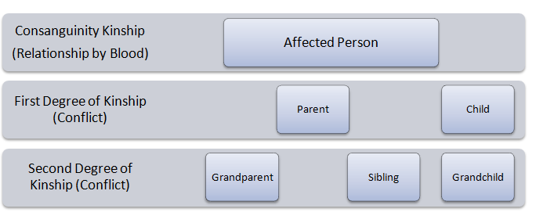
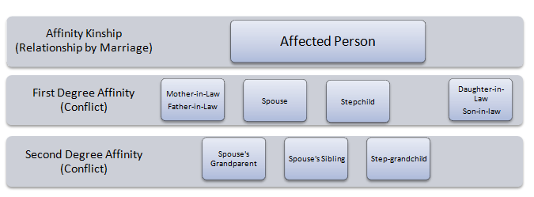

Reasonable accommodations will be made for persons with disabilities and language assistance will be made available for persons with limited English proficiency. Individuals who require these services should contact Homeless Programs staff at homelessprograms@tdhca.texas.gov so the appropriate arrangements can be made.

