|  |  |
| --- | --- |
| **DETERMINATION OF CONFLICT OF INTEREST** | |
| **Administrator:** | **Contract Number:** |
| **Applicant:** | |
| **Description of Situation:** | |

|  |
| --- |
| **Part 1 – Affected Persons** |

|  |  |  |
| --- | --- | --- |
| Applicant’s application for HOME Program assistance is subject to conflict of interest regulations at 24 CFR 92.356 as a result of his/her relationship with the following Affected Person who is associated with the Administrator:: | | |
| **Affected Person’s Name** | |  |
| **Affected Person’s Position with Administrator** | | Employee  Agent  Consultant  Officer  Elected or appointed official  Other: |
| **Affected Person’s Relationship**  **to Applicant** | | Self  Member of Applicant’s family within 2 degrees of consanguinity or affinity as shown on Attachment 1: Relationship Charts.  Partner with Applicant  Associated with an organization that employs or is about to  employ Applicant  Has a financial or other interest in or with Applicant  Other: |
| 1. Does the Affected Person exercise any function or responsibility with respect to the HOME Program currently or in the past? | | |
| No | Yes. Describe function/HOME responsibilities: | |
| 2. Is the Affected Person in a decision-making role with the Administrator with respect to the HOME Program currently or in the past? | | |
| No | Yes. Describe role: | |
| 3. Is the Affected Person in a position in which he/she may have gained inside information regarding the HOME Program currently or in the past? | | |
| No | Yes. Describe position: | |
| If the answers to ***all*** of the above questions are “No”, complete *“Part 2-Certification of NO Conflict”* and submit to TDHCA for review. | | |
| If the answer to any of the above questions is “Yes”, a **prohibited conflict may exist**.   * Deny assistance in accordance with Administrator’s procedures; or * Complete “Part 3 – Request for Exception” and submit to TDHCA for approval. | | |

|  |  |
| --- | --- |
| **Part 2 - Certification of NO Conflict of Interest** | |
| **Warning: It is a violation of Title 18, Section 1001 of the U. S. Code states for a person to knowingly and willfully make false, fictitious, or fraudulent statements in any matter within the jurisdiction of the executive, legislative, or judicial branch of the Government of the United States.** | |
| “I hereby certify under penalty of law that I am not a person who exercises, or has exercised, any responsibility with respect to the activities assisted with HOME Program funds. I am not, and have not been, in a position to participate in a decision-making process with respect to HOME Program activities. I have not been in a position to gain inside information with regard to HOME Program activities.” | |
| **Signature of Affected Person:** | **Date:** |
| “Administrator certifies under penalty of law that this information is true and correct and that provision of HOME Program assistance to Applicant would not constitute a conflict of interest as discussed at 24 CFR §92.356.” | |
| **Signature of Contract Administrator:** | **Date:** |

|  |
| --- |
| **Part 3 – Request for Exception to Conflict of Interest** |

|  |  |
| --- | --- |
| All exceptions must be submitted for review by TDHCA Legal on a case-by-case basis.Upon review, TDHCA may make a written request that the exception be submitted to HUD for final determination and approval. Only HUD has the authority to make the final determination regarding disposition of a conflict of interest and/or to approve a request for exception. Activities for which an exception is required may not be submitted to TDHCA for approval until an exception has been granted by HUD. Do not proceedwith assistanceto Applicant until receiving final written authorization from TDHCA and HUD. | |
| 1. Provide a detailed explanation of the nature of the conflict:  Describe: | |
| 2. Will the exception result in a significant cost benefit, expertise, or other benefit to the administration of the Program which would not otherwise be available? | |
| No | Yes – Describe: |
| 3. Is the Applicant a member of a group or class of low-income Persons intended to be the beneficiaries of the assisted activity? | |
| No | Yes – Describe: |
| If Yes, will the exception permit Applicant to receive the same type of benefits made available to other  members of the group or class? | |
| No | Yes – Describe: |

|  |  |  |
| --- | --- | --- |
| 4. Has the Affected Person recused himself/herself and/or withdrawn from any functions, responsibilities, and/or decision-making obligations with respect to the assisted activity? | | |
| No | Yes – Describe: | |
| 5. Was this HOME Contract available before the Affected Person became subject to the potential conflict? | | |
| No | Yes – Describe: | |
| 6. Will denial of the benefit result in any undue hardship when weighed against the public interest served by avoiding the conflict? | | |
| No | Yes – Describe: | |
| 7. Were applicable affirmative marketing procedures conducted? | | |
| No | Yes – Describe: | |
| 8. Provide other relevant information: | | |
| 9. Attach evidence of the public disclosure of the conflict, which must include **printing the disclosure in a local newspaper or similar publication**. The publication must adequately reach all residents of the Administrator’s entire Service Area and may require use of multiple publications. Only posting a public notice in the Administrators’ office space is insufficient. | | |
| 10. Attach a written statement from an attorney representing the Administrator confirming that no state or local law would be violated as a result of the issuance of an exception to the conflict of interest requirements. | | |
| 11. Attach documents evidencing that the Affected Person has withdrawn from his or her functions or responsibilities with respect to the HOME Program. | | |
| 12. Attach a resolution from Administrator’s governing body confirming that Administrator intends to request an exception to the conflict of interest requirements from HUD. | | |
| **Warning: It is a violation of Title 18, Section 1001 of the U. S. Code for a person to knowingly and willfully make false, fictitious, or fraudulent statements in any matter within the jurisdiction of the executive, legislative, or judicial branch of the Government of the United States.** | | |
| Contract Administrator hereby certifies under penalty of law that the information provided herein is true and correct, and requests an exception to applicable conflict of interest regulations in order to provide HOME Program assistance to the above-referenced Applicant. | | |
| **Signature of Contract Administrator:** | | **Date** |
| **Attachment 1: Relationship Charts** | | |

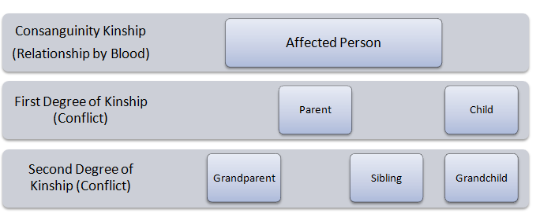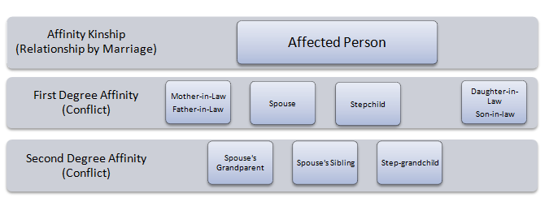

*Reasonable accommodations will be made for persons with disabilities and language assistance will be made available for persons with limited English proficiency.*

|  |  |  |
| --- | --- | --- |
|  | **Texas Department of Housing and Community Affairs**  Street Address: 221 East 11th Street, Austin, TX 78701 Mailing Address: PO Box 13941, Austin, TX 78711  Main Number: 512-475-3800 Toll Free: 1-800-525-0657 Email: info@tdhca.texas.gov Web: www.tdhca.texas.gov |  |