Texas Department of Housing and Community Affairs (TDHCA)
Multifamily Finance (MF) Serv-U Hypertext Transfer Protocol Secure (HTTPs)
TDHCA MF Serv-U HTTPs User Guide

Organizations interested in applying for Housing Tax Credits (HTC) or Multifamily Direct Loan funds must complete the following steps to submit their applications/deficiencies/forms/reports electronically (applications are NOT accepted via mail, CD, or email):
- The Electronic Filing Agreement is included within the online 2020 Competitive (9%) HTC Pre-Application. If a 2020 9% Pre-Application is submitted, there is no need to submit an Electronic Filing Agreement.
- If you did not submit a 2020 9% HTC Pre-Application and you intend to submit a 2020 9% HTC Application, the Electronic Filing Agreement must be submitted by February 14, 2020 in order to ensure enough time for the Department to assign a username for you to create the account and set up the password.
- For 4% Housing Tax Credit Applications, the Electronic Filing Agreement should be submitted 3-5 business days prior to the anticipated application submission date.
- For Multifamily Direct Loans, if the application is submitted as part of a 4% or 9% HTC application, no additional Electronic Filing Agreement is required. Otherwise, the form should be submitted 3-5 business days prior to the anticipated application submission date.
- Please email the form to Liz.Cline@tdhca.state.tx.us and Jason.Burr@tdhca.state.tx.us.
  - The Electronic Filing Agreement is available on the TDHCA website at: http://www.tdhca.state.tx.us/multifamily/apply-for-funds.htm
- Log into the TDHCA Multifamily Serv-U HTTPs system with the username assigned to the application.
  - You are responsible for completing the setup of the Serv-U HTTPs to ensure that your account is ready for the full Application to be uploaded by the deadline (February 28, 2020, by 5:00 p.m., Austin local time). We strongly recommend that you test your login as soon as you receive the setup email containing your MF Serv-U HTTPS login information so that any issues can be resolved well before the appropriate deadline.
- Upload the full Application and related documents.
  - We strongly recommend uploading the application file(s) well before the submission deadline so any problems that arise can be addressed prior to the submission deadline.
- Use this same system to upload all deficiency responses and subsequent forms/reports. Always email the TDHCA staff member awaiting the submission.
TDHCA is including instructions for each of these steps. In addition, a reference section with general information about the system is included as Section 5.

Instructions:
Submitting an Electronic Filing Agreement
As stated above, the Electronic Filing Agreement Form was included in the 2020 9% HTC Pre-Application. If you did not submit a Pre-Application, you must submit an Electronic Filing Agreement Form by completing the form located at (http://www.tdhca.state.tx.us/multifamily/apply-for-funds.htm). Please email the form to Liz.Cline@tdhca.state.tx.us and Jason.Burr@tdhca.state.tx.us. The form must be received by 5:00 p.m. on February 14, 2020.
Once you have submitted your request, we will create your login and email your Login ID and a web link to these instructions to the Owner and Consultant or 2nd Contact(s). Only the Owner will receive temporary passwords and have authority to create new passwords.

Recovering your Password for the TDHCA MF Serv-U HTTPs System
To log into the TDHCA Multifamily Serv-U HTTPs System, first find the Login ID that was emailed to you (may need to check your SPAM or JUNK email folder). After you have your username go to the following website (https://mf-files.tdhca.state.tx.us/) and click on Recover Password. See Figure 2—1.

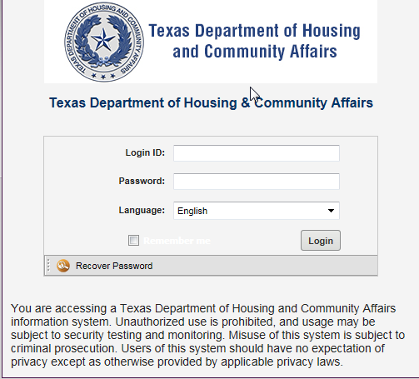
Figure 2—1
Enter your username in the Login ID box on the Recover Password screen and click OK. A new password will be emailed to the Owner’s email address. (See Figure 2—2 and 2-3)
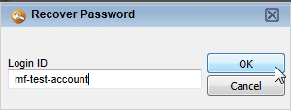
Figure 2—2

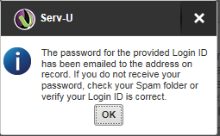
Figure 2-3

Logging into the TDHCA MF Serv-U HTTPs System
To log into the TDHCA Multifamily Serv-U HTTPs System, go to the following website (https://mf-files.tdhca.state.tx.us/) and enter your username in the Login ID box and your temporary password into the Password box. Click the Login button to log into the system. (See Figure 3—1).

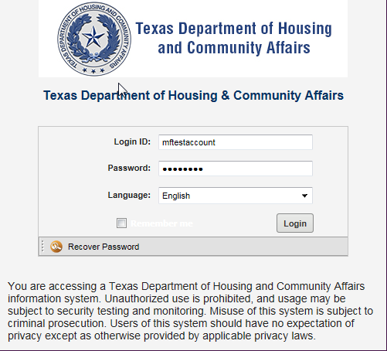
Figure 3—1
You will be prompted to CHANGE PASSWORD. The New Password must be at least 8 characters and contain numbers, upper and lower case letters. NO SYMBOLS will be accepted.

Uploading all application documents, including all attachments
Once you have logged into your account, you can view any information that has been uploaded to your account. To upload an application document, click the Upload button located at the top left of the screen (See Figure 4—1).

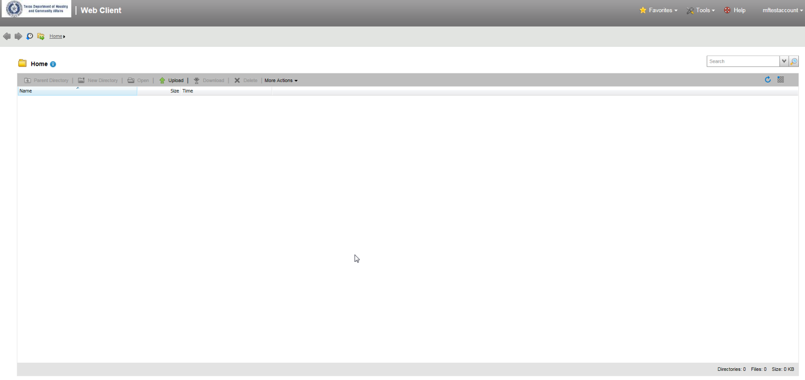
Figure 4—1
Clicking the Upload button will pop up the Upload Window. Click the Browse button to navigate to the location where you saved the application documents (Figure 4—2). In this example, a test document is saved on the hard drive at the following location: c:\Users\lcline\Desktop\.

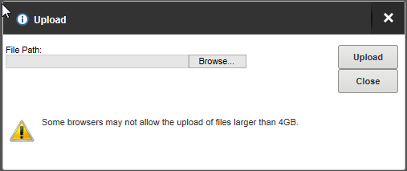
Figure 4—2
After you click the Browse button, navigate to the location where you saved your file(s) on your computer hard drive, flash drive or desktop. Once you have successfully navigated to the file, click on the file and then the location of the file will be placed into the File Path box. Now click the Upload button to upload the file to TDHCA (Figure 4—3).
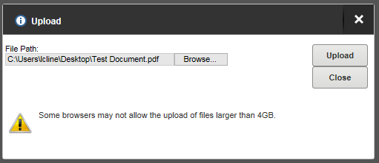
Figure 4—3

If you have more than one file to upload, you can repeat the last two steps of browsing for a file and uploading additional files. After you complete the upload process, click on the Close button to review the file or files that have been uploaded to TDHCA (Figure 4—4).

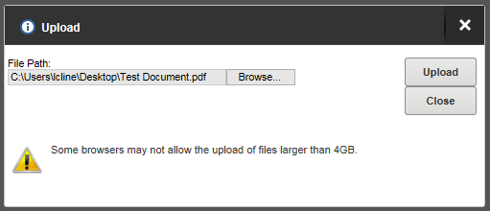
Figure 4—4
The upload process is now complete and you will be able to view the files that you uploaded to TDHCA. In the window you will be able to see the name of the file under the Name heading, the size of the file under the Size heading, and the time the file was received under the Time heading. After uploading multiple files, you will be able to sort the documents by each of these headings (Figure 4—5).
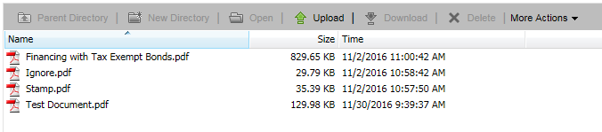
Figure 4—5

 Important Note Regarding Document Uploads
If a document is uploaded by mistake, please give the replacement file a different name and upload it. You will need to email Jason Burr at jason.burr@tdhca.state.tx.us or Liz Cline at liz.cline@tdhca.state.tx.us to have the mistaken document removed.

Review documents
The screen print in Figure 5-1 shows the main screen that will be available when you are logged into the TDHCA U-Serv HTTPs System. In this screen you can view all of the documents that have been uploaded to the system. The window will show the name of files, size of files, and the time the files were received.
Files can be sorted by each of the previously mentioned headings (Name, Size, and Time). Any files that you see when you are looking at this screen are in the system and have been uploaded to TDHCA. These are the files that TDHCA staff will access. Applicants should ensure that uploaded documents open properly when they are selected and that they contain all of the information that the applicant meant to send.
Figure 5-1

 Important Note Regarding Submission Time
Submission Time
The time displayed on the screen shows the time the file completed the download process and the entire file was received by TDHCA, it does not indicate the time that the file submission began.
NOTE: Applicants must understand that the upload time of each file will depend on the file size, the speed of the internet connection, and the number of users accessing the server at a given time. Applicants that wait until close to the submission deadline to upload their documents may not meet the deadline. Applications are NOT accepted via email or any other delivery mechanism.

Saving Screen Print as submission confirmation
In the main screen, make sure that all of the submitted documents are clearly visible. Next, press the print screen button on your keyboard. This will take a copy of your screen and save it to your clipboard. Next open Microsoft Word, Wordpad, or your preferred document editing software. After the software is open, use the paste button to place the print screen into the document. Serv-U HTTPs does not automatically notify Multifamily staff when a file has been uploaded. It is the applicant’s responsibility to contact Multifamily staff and make them aware that the file(s) have been uploaded.

General Information about the system: description of information displayed and function of buttons
Main Screen
When you are logged into the system you will see the screen in Figure 7—1. This is the main screen of the TDHCA U-Serv HTTPs System. This screen displays the files that you have uploaded to TDHCA and information about the files and system.
Figure 7—1

Refresh Button
The Blue arrow is the refresh button. It will refresh all the information displayed on the screen. (See Figure 7—2)

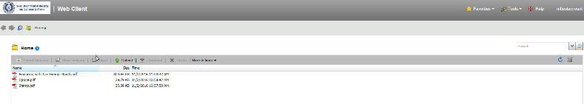

Figure 7—2
Log In Name
The system will show the username of the logged in account in the top right corner. (Figure 7—3)


Figure 7—3
Useful Buttons
In (Figure 7—4) we have included an overview of some of the buttons you may find useful.

Figure 7—4
- 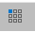 Change View – Allows the user to change the view of uploaded items from thumbnail view to details view and vice versa.

- Change Password -- Allows the logged in user to change the password of the account if the user has been granted such permission.
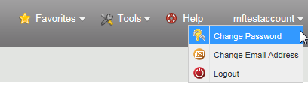

- Change Email -- Allows the logged in user to change the email address for the account if the user has been granted such permission.
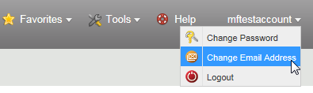
- Help – Gives access to the help menu.
- Logout – Allows user to logout of the system after you have completed your upload.
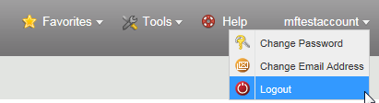
Menu Bar
At the bottom of the Window there is another menu bar with several useful functions and information that you will be able to use while logged into the system (Figure 5—5). The buttons are explained below:

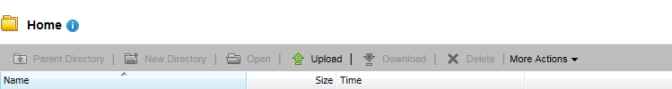
Figure 5—5
- Upload -- Upload begins the upload process.
- Download – Only visible when you have a file selected in the main window. Click download to download the file that you have selected.
- Rename -- You will not be able to rename files once they have been uploaded to TDHCA.
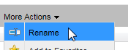
- Delete – You will not be able to delete files once they have been uploaded to TDHCA.
- Directory Properties – Displays the properties of the folder.
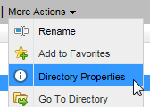
- At the bottom right of the screen, the system will list the number of directories, files, and the size of all your files.

